In .dat file:
Now, Population weight at age & Maturity at age are in .ctl file

Before After
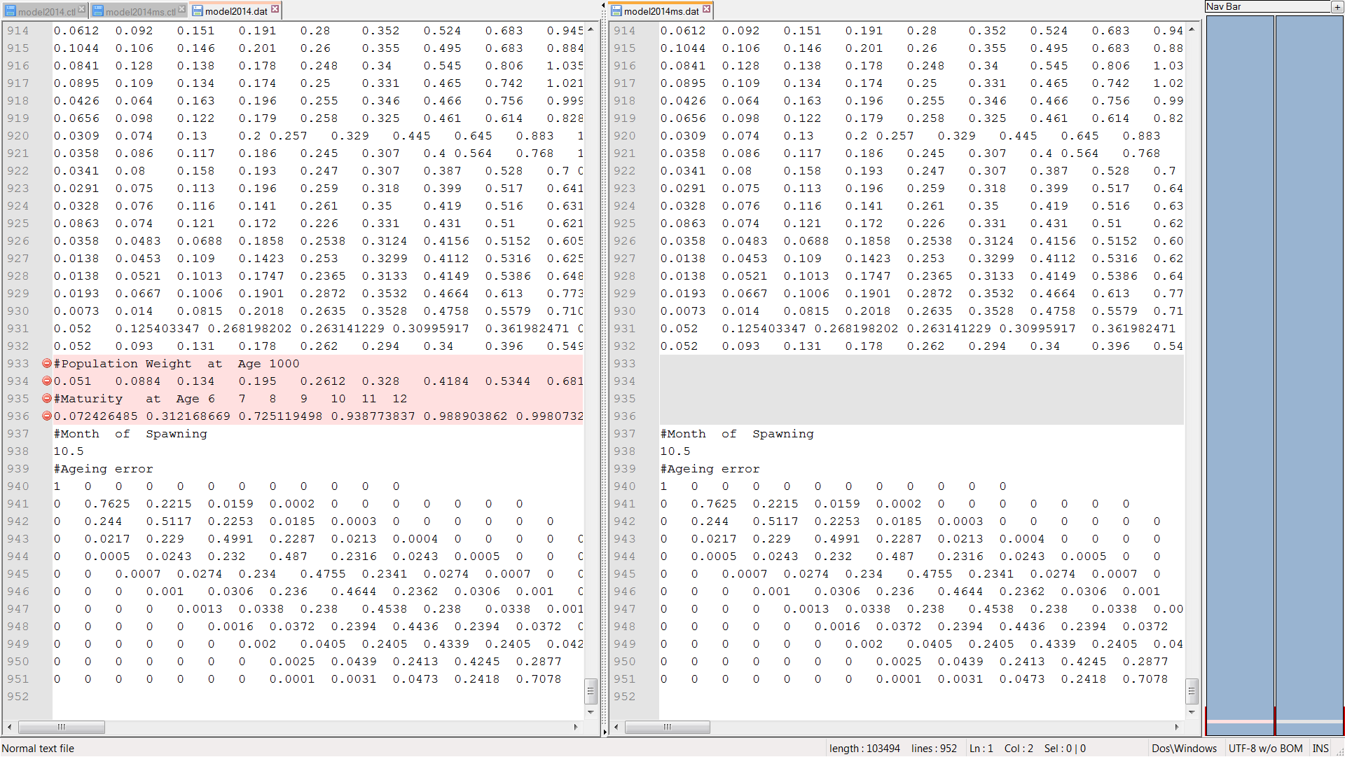

In .ctl file:
- You have to specify the number and name of the stocks.
- In the matrix of selectivity add a row before, where row 1 is index of stock.
- After the matrix of selectivity, specify in a vector the number of regimes (by stock).

Before After
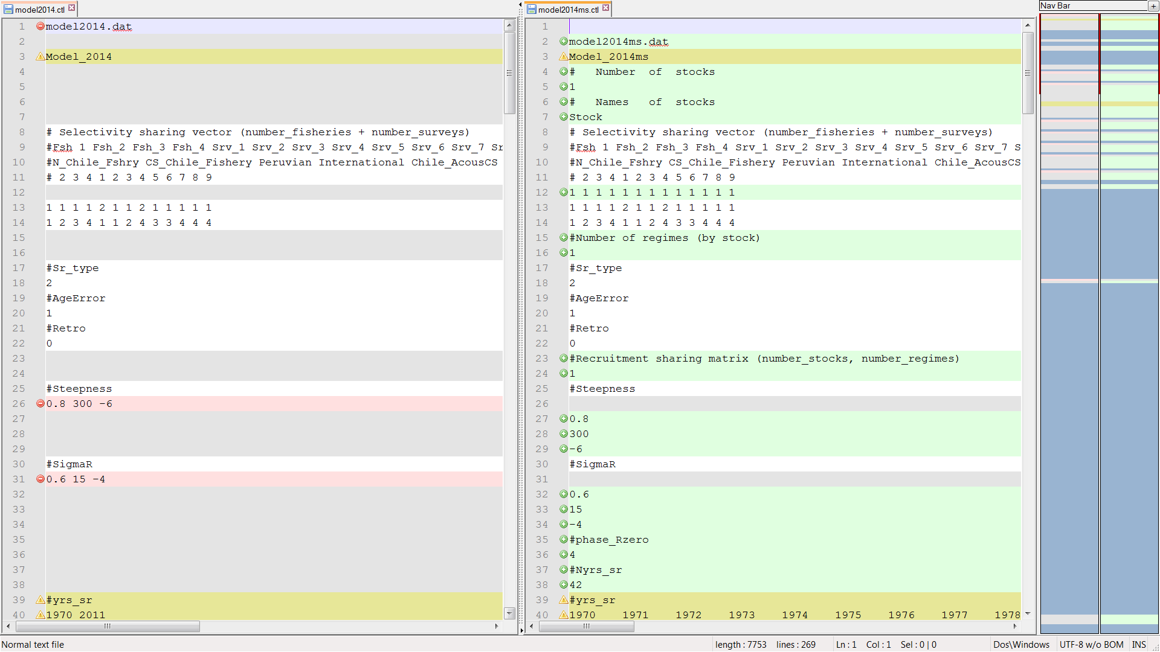
2
1
3

With the number of stocks and the number of regimes by stock, we construct three ragged arrays (recruitment, growth and natural mortality). Each row is a stock and each column is a regime.
These arrays specify if the regime is using a new set of recruitment, growth or natural mortality parameters.

Recruitment array:
- Specify the recruitment array (number of stocks, number of regimes)
- Steepness (cv and phase) by each set of parameters in the recruitment array.
- SigmaR (cv and phase) by each set of parameters in the recruitment array.
- Phase_R by each stock.
- Number of years that we want to fit in the SR-curve.
- Years that we want to fit in the SR-curve.
- Years where there are a regime shift.

Before After
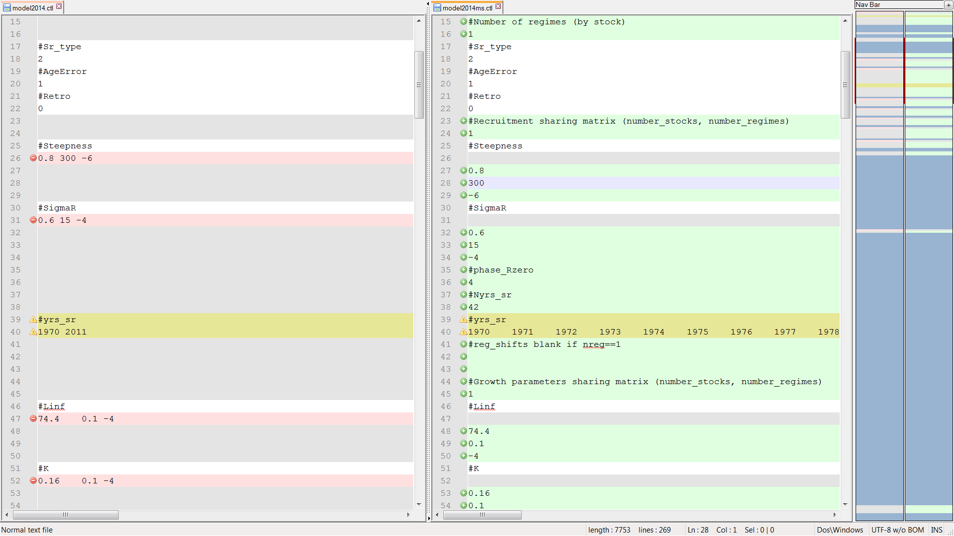
6
4
1
2
7
5
3

Growth array:
- Specify the growth array (number of stocks, number of regimes)
- Linf (cv and phase) by each set of parameters in the growth array.
- K (cv and phase) by each set of parameters in the growth array.
- Lo_Len (cv and phase) by each set of parameters in the growth array.
- Sigma_Len (cv and phase) each set of parameters in the growth array.

Before After
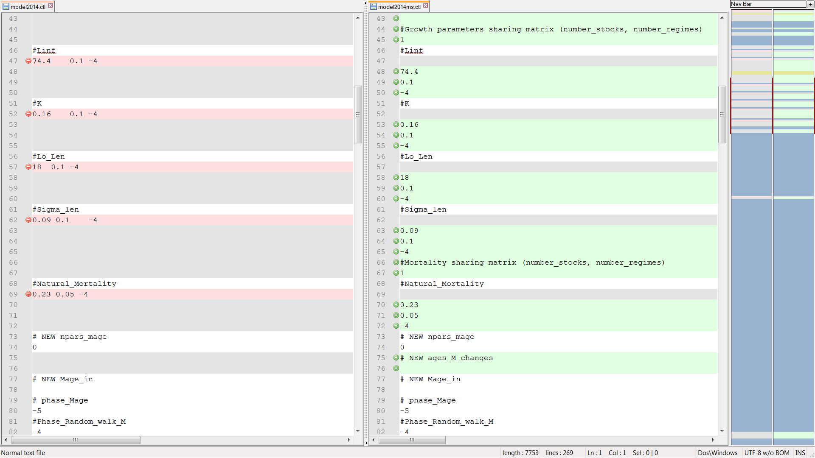
4
2
5
3
1

Natural mortality array:
- Specify the natural mortality array (number of stocks, number of regimes)
- Natural mortality (cv and phase) by each set of parameters in the natural mortality array.

Before After
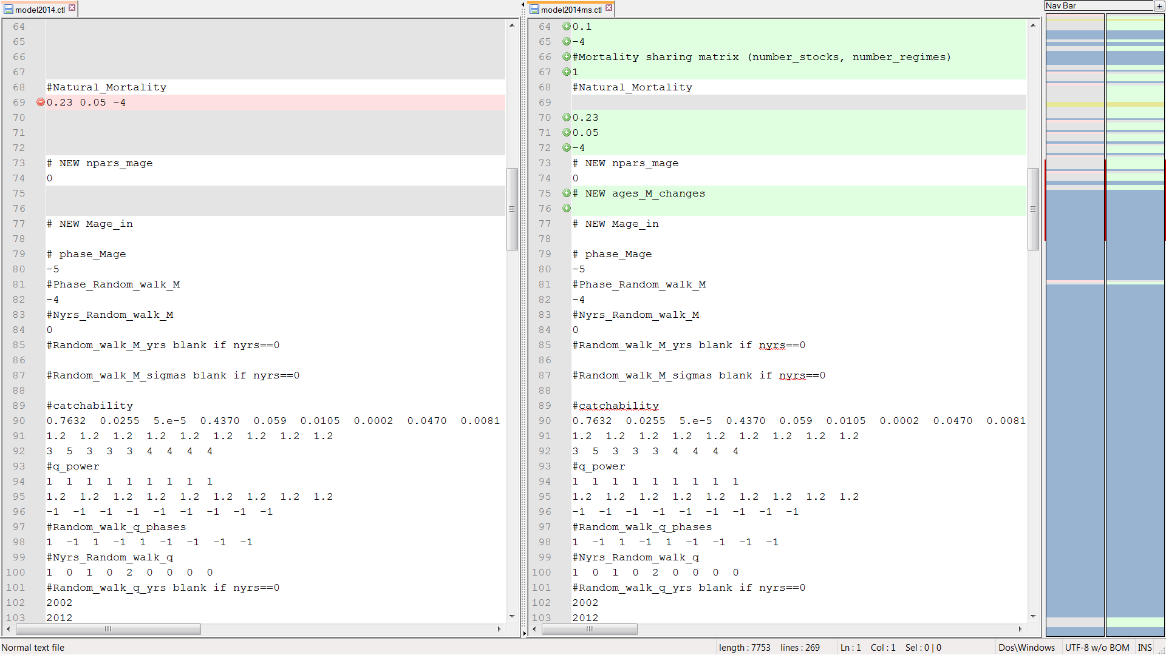
2
1

Finally, add the Population weight at age and Maturity at age vector in the .ctl file

Before After
